DMXW Tester:
User Manual

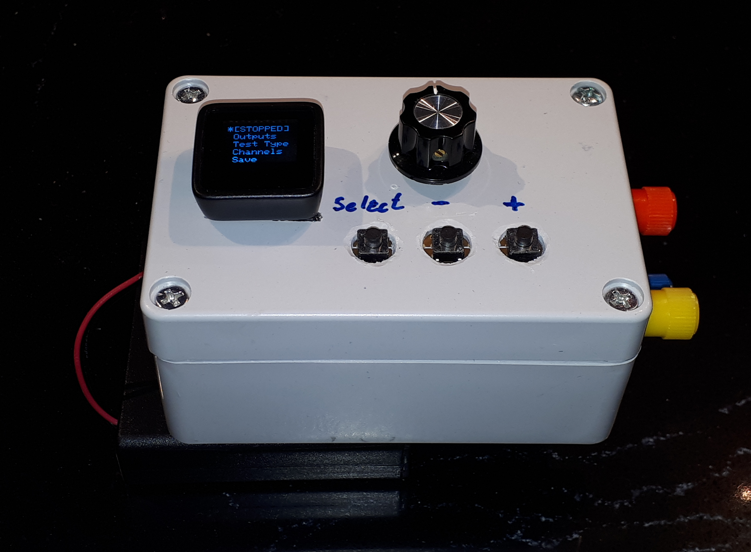

A. John van Schouwen
May 2, 2020

Overview
The DMXW Tester is a mobile, battery operated tool that provides the user with the capability of running basic tests on DMXW remote slave nodes and for running basic onboard tests for devices and circuits that are ultimately intended to be connected to a DMXW remote slave node.
The DMXW Tester is convenient for quick testing of DMXW remote slave nodes in a backstage environment. However, since the tester would otherwise interfere with a DMXW Gateway’s control of onstage effects, tests normally should not be conducted while stage effects are onstage and in sight of a live audience—unless the tester’s radio is isolated (shielded) from the onstage DMXW Gateway. This rule can be broken as long as all of the following conditions are met:
- There is no expectation that any onstage effects need to operate while the offstage tests are being run;
- None of the onstage effects are selected as active in the tests; and,
- A zero channel value for each DMXW channel that is associated with any onstage effect (and those channels all being inactive in the test) results in every one of those onstage effects being inactive.
The following features are available:
- DMXW remote slave testing:
  - Up to the maximum number (48) of DMXW channels can be selected as active for testing.
    - Channel values for all non active channels are all set to zero.
  - Channels values can be modified one-at-a-time, via the onboard potentiometer.
  - One channel can be assigned to be under continuous potentiometer control.
  - The types of tests that can be run are:
    - Manual testing, in which each active channel’s value is adjusted only via manual control at the test unit.
    - Sweep testing, in which the tester continuously sweeps from values 0 thru 255, and back down to 0, on each active channel, one-at-a-time.
- Onboard testing:
  - Four PWM (pseudo analogue) channels are available and operate in the same way as the four PWM channels on a DMXW remote slave node.
    - Since the onboard channels have less cooling capacity as a slave node, circuits that draw high current should be run for very short durations only to avoid burning out a channel’s N-channel MOSFET.
    - As with the slave nodes, the external loads that are connected to these channels must be connected to a positive voltage source (up to 60 volts) with the external voltage source’s negative (ground) connector connected to the onboard ground connector. The external load’s negative connection connects to the onboard channel’s connector.
  - One low-current digital output channel that can operate at either 3.3 Vdc (as would be native on a DMXW remote slave node) or at 5 Vdc (using an internal logic level converter circuit)
    - The 3.3V and 5V output can handle up to about 40 mA of current, collectively.
    - The 5V digital output can be used to drive an addressable LED pixel strip. (Only 12 Vdc pixel strips are recommended, and an external 12V power source would be required.)
NOTE: There’s some wonky behavior on the onboard 5 Vdc digital output. However, with the exception of a 5 Vdc addressable LED pixel strip, this shouldn’t create problems. Just be aware of circuits that require high frequency voltage transitions.
  - One 5 Vdc constant voltage source output that is capable of supplying a few hundred milliamps of current.
  - Up to all five of the onboard channels can be selected for active testing.
    - Channel values for all non active channels are all set to zero.
  - Channels values can be modified one-at-a-time, via the onboard potentiometer.
  - One channel can be assigned to be under continuous potentiometer control.
  - The types of tests that can be run are:
    - Manual testing, in which each active channel’s value is adjusted only via manual control at the test unit.
    - Sweep testing, in which the tester continuously sweeps from values 0 thru 255, and back down to 0, on each active channel, one-at-a-time.
    - Pixel strip testing, in which an addressable LED pixel strip (12 Vdc) runs an animated rainbow pattern whose speed can be controlled by the onboard potentiometer.
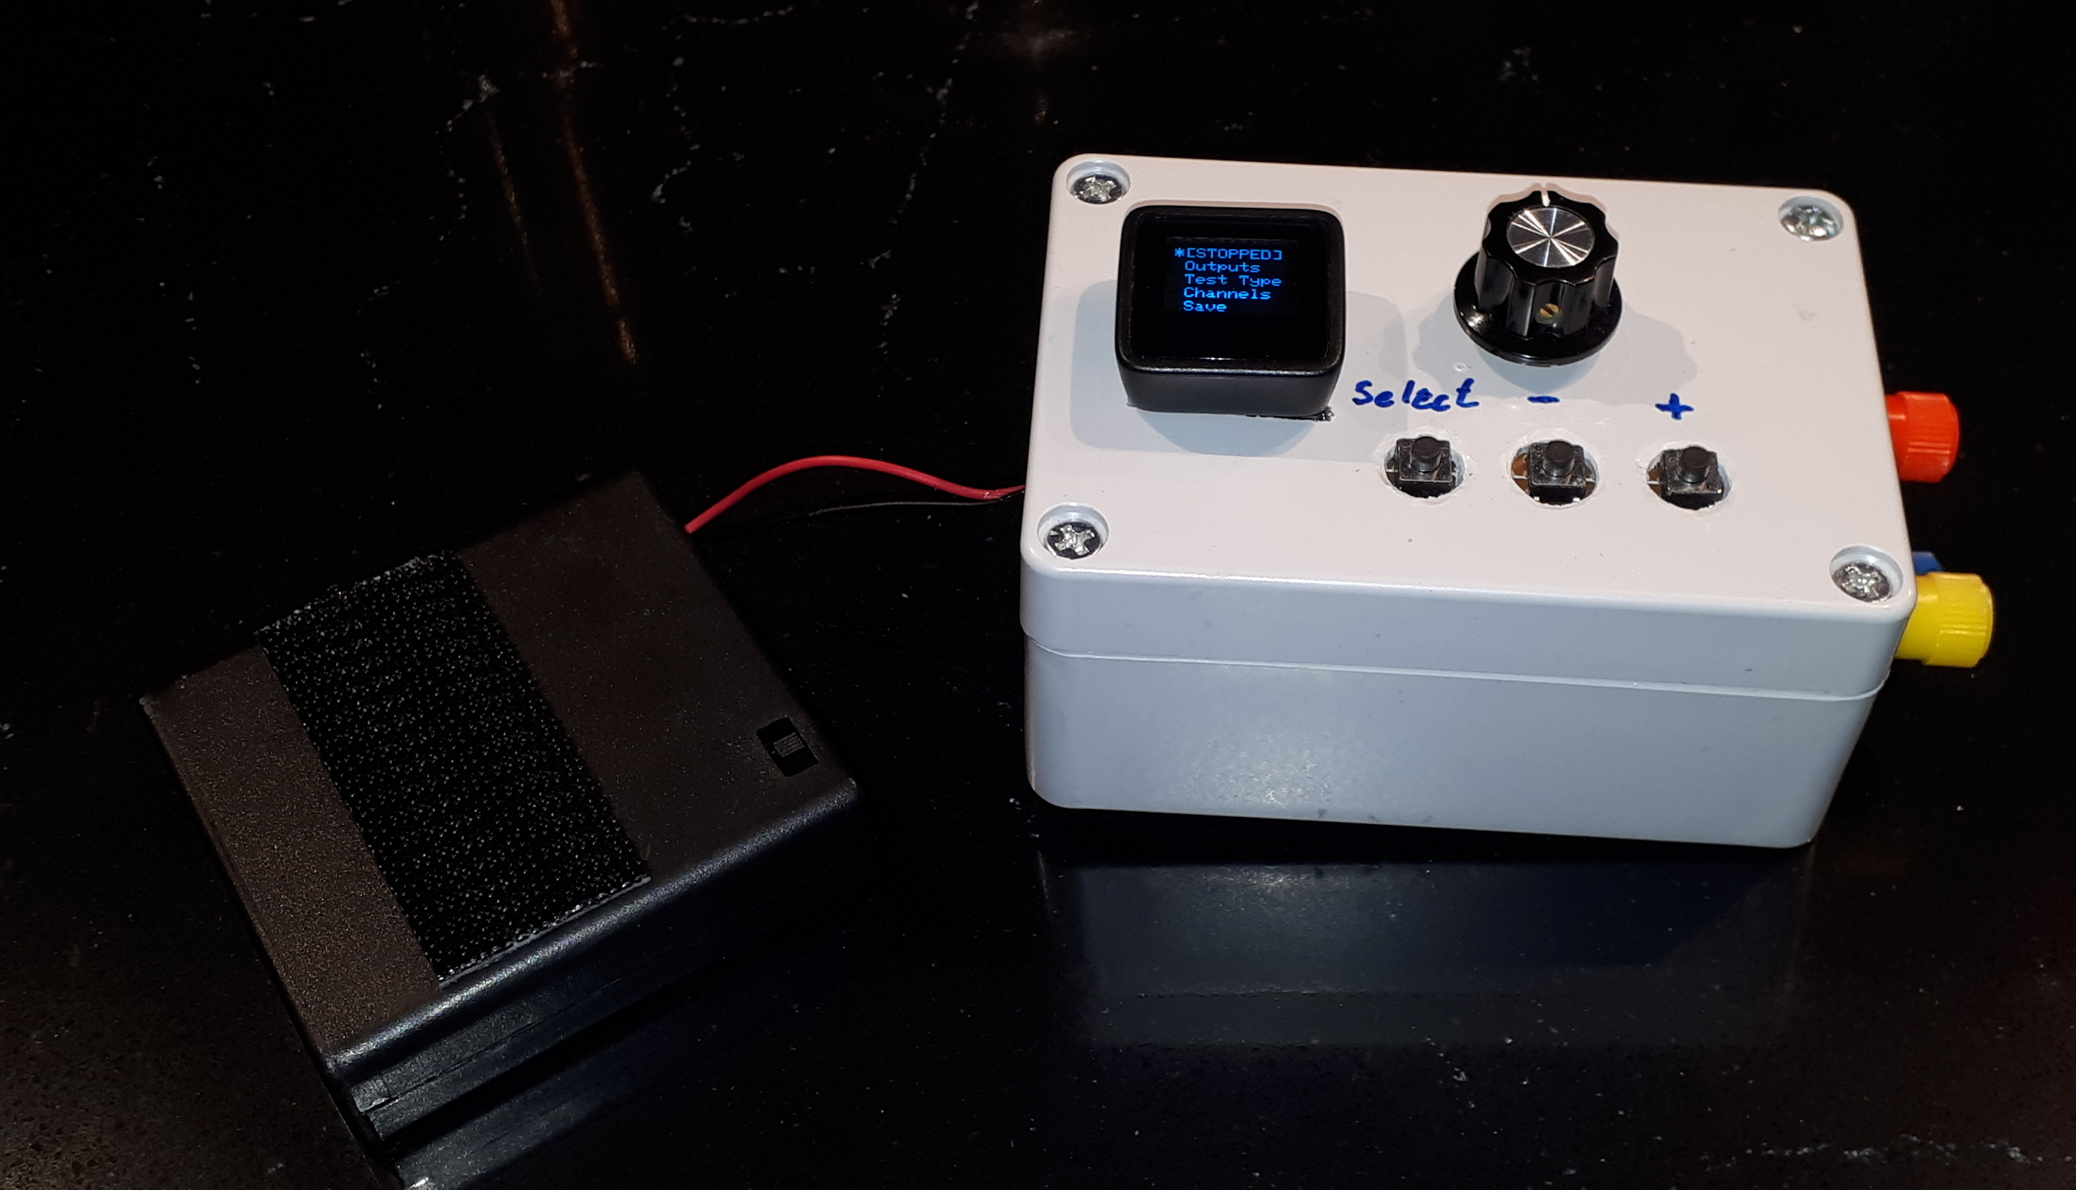Figure 1: DMXW Tester - Top (control panel) view

Onboard Connections
Figure 2 shows the connectors for onboard channels #1 thru #4 and for the ground connection. Each of the channel connectors here should connect to the negative (or ground) side of the channel’s load. The load’s positive side should connect to the positive side of the load’s external power supply. The ground side of the load’s power supply should connect to the onboard ground connector.
Figure 2: DMXW Tester - Connections for channels #1 - #4 and ground

Figure 3 shows the digital output channel #5 with its +3.3 Vdc (yellow connector) and +5 Vdc (red connector). The blue connector is the +5Vdc constant voltage source.
Figure 3: DMXW Tester – Connections for digital channel #5 and +5Vdc constant voltage

Menus
Figure 4 illustrates the banner that’s displayed for a couple of seconds after powering on the tester. This screen is immediately followed by the top level menu shown in Figure 6:
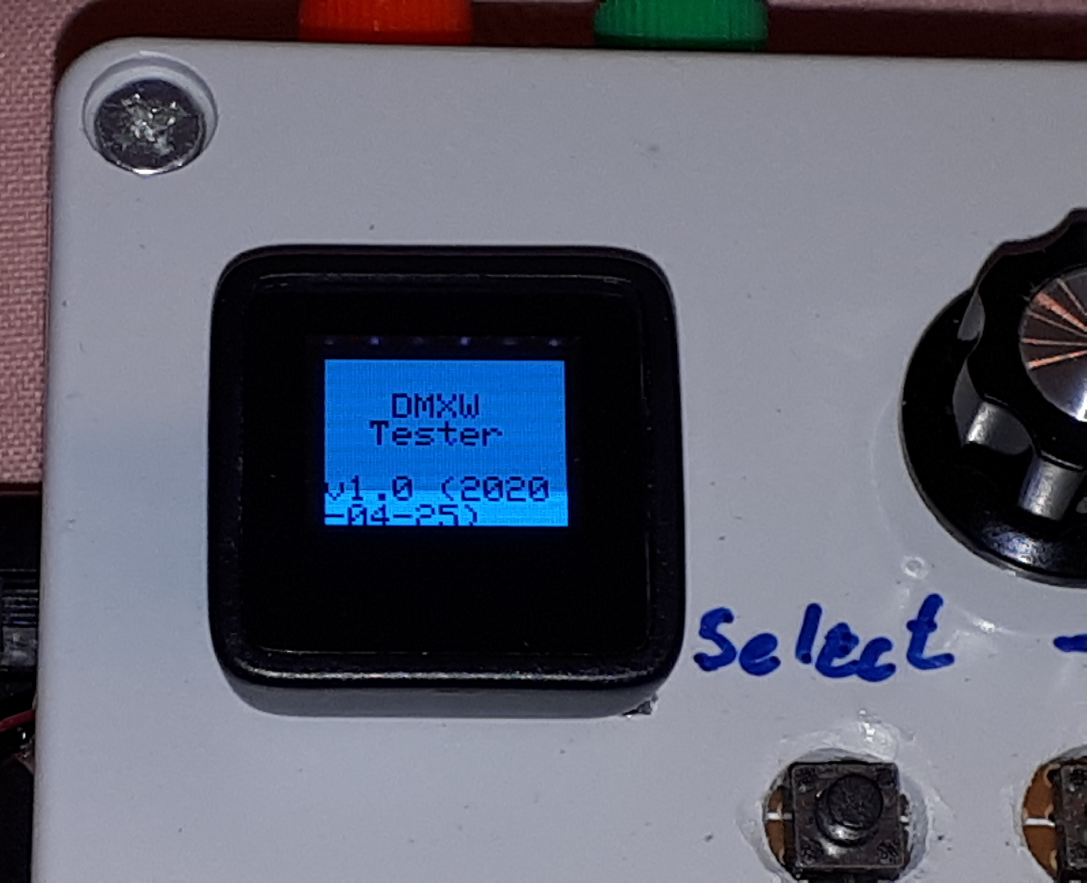Figure 4: Startup banner
- The first menu item in the list (in square brackets) shows the current test state (STOPPED, RUNNING, and PAUSED). Selecting that item (described subsequently) takes you to the Test State menu (shown in Figure 7) where you can change the state of testing as well as configuring the length of an addressable LED pixel string, if one is attached to onboard digital output channel #5.
- Selecting the Outputs item takes you to the outputs menu (shown in Figure 9) where you can select whether to run a test using the DMXW network or the onboard output channels, and where you can modify the output channel values.
- Selecting the Test Type items takes you to the test type selection menu (shown in Figure 11) where you can select the type of test you want to run.
- Selecting the Channels item takes you to the active test channel selection menu (shown in Figure 12) where you can select which channels are to be active in your test, and where you can select a single one of the active channels to be controlled by the onboard potentiometer.
- Selecting the Save item causes all of the following test parameters to be saved and reactivated automatically when you next power on the tester (the save will be confirmed briefly as shown in Figure 5):
  - The currently selected test type and outputs.
  - The most recently active test channels and which, if any, of the test channels is assigned to the potentiometer (for both onboard and DMXW tests).
  - The most recently assigned active test channel values (for both onboard and DMXW tests).
  - The most recently configured LED pixel strip length value.
To navigate the menu:
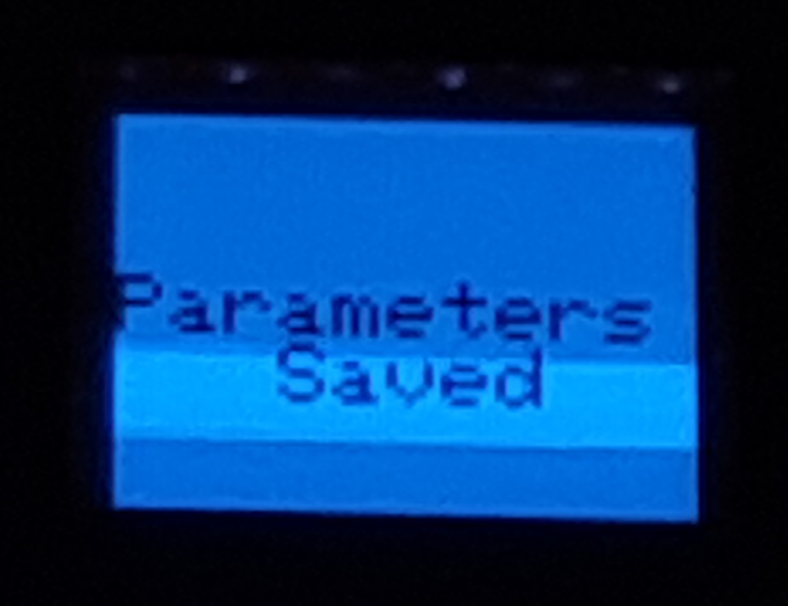Figure 5: Saving test parameters
- Note that the currently menu item position is indicated by the asterisk (*) to the left of the menu items.
- Use the + and – buttons to move down and up the screen (respectively). The menu position wraps around (from bottom to top, or top to bottom) in this menu.
- Press the Select button to select the menu item.

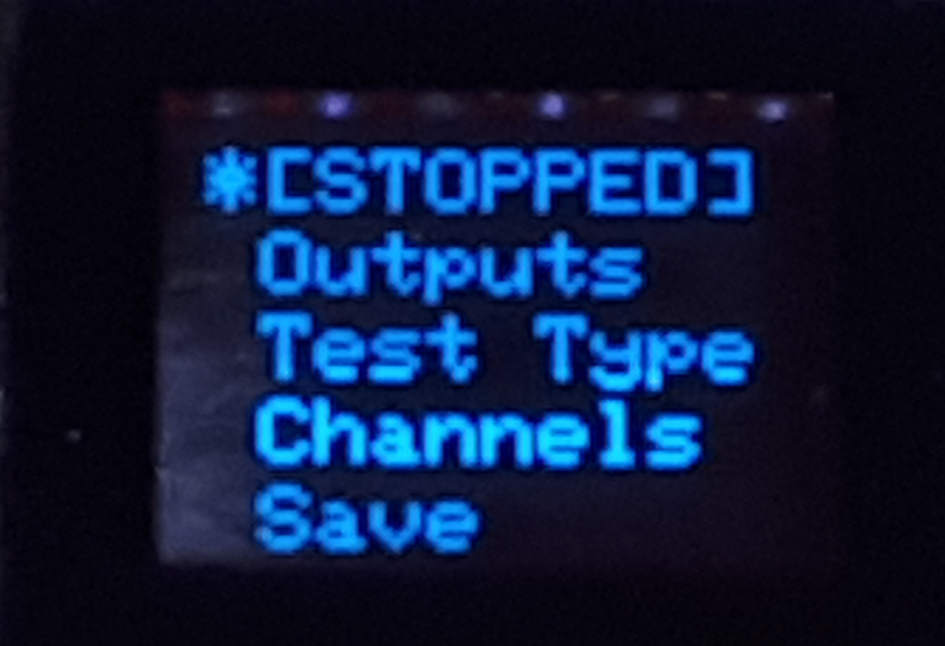Figure 6: DMXW Tester's top level menu
Note: The test type, test outputs, and active channels can be changed only while there is no test in progress (i.e. the test state must be STOPPED).
Figure 7 shows the Test State Selection menu. Use the + and – buttons to move the menu position indicator, and the Select button to select the corresponding item. The menu items are as follows:
- The first item says STOPPED if there is no test currently running; selecting this item has no effect in this case. Otherwise, the item says STOP, in which case selecting it will stop a running or paused test.
- Unless a test is already paused, the second item says PAUSE; selecting it in this case pauses the current test and requires you to either select RUN or STOP to proceed. Otherwise, the item says PAUSED and selecting has no effect.
- The third item says RUNNING if a test is already actively running; selecting it in this case has no effect. Otherwise, the item says RUN and selecting it causes a test to start or resume.
- Selecting the Pixel len item takes you to the addressable LED pixel strip length configuration menu shown in Figure 8.
- Selecting the <back> item takes you back to the top level menu.
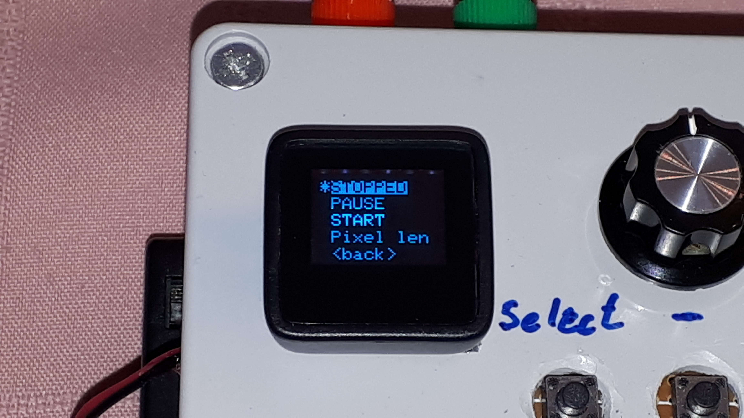Figure 7: Test state menu and pixel length
Figure 8 shows the Pixel String Length Configuration menu. If you have an addressable LED pixel string connected to 5 Vdc connector for digital output channel #5, you need to tell the tester how many individually controllable pixels there are in the string. (Note that pixel strings that run on 12 Vdc typically group three tricolor LEDs together as one pixel.) A length must always be entered as three digits—leading digits can be zero. When you first enter the menu, the leftmost digit will be highlighted. Press the + and – buttons to increase or decrease the digit value and the Select button to select that digit value and move the next digit. Once you’ve selected the value for the rightmost digit, you will automatically be taken back to Test State Selection menu.
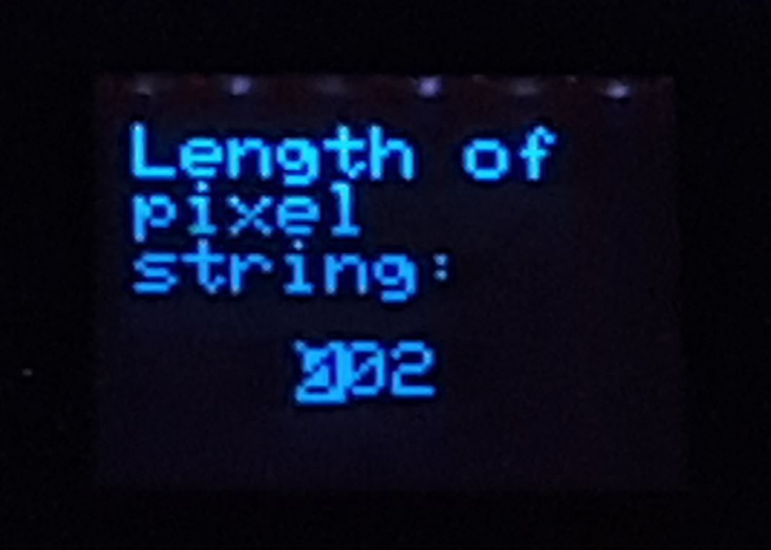Figure 8: Pixel string length configuration
Figure 9 shows the Test Output Selection menu. You can configure parameters for both onboard and DMXW channel tests. However, only the currently selected test outputs are used for an active test. The menu items are as follows:
- Select None if you wish to disable all outputs for the time being.
- Select Onboard for any or all of onboard channels #1 thru #5.
- Select DMXW to test any or all of the 48 DMXW channels.
- Select the Values… item if you wish to set specific values for your selected active test channels (refer also to Figure 12). When a test is running, you can also go to this menu to modify the channel values on-the-fly. Selecting this item takes you to the Channel Output Value Modification menu shown in Figure 10.
- Select <back> to go back to the top level menu.
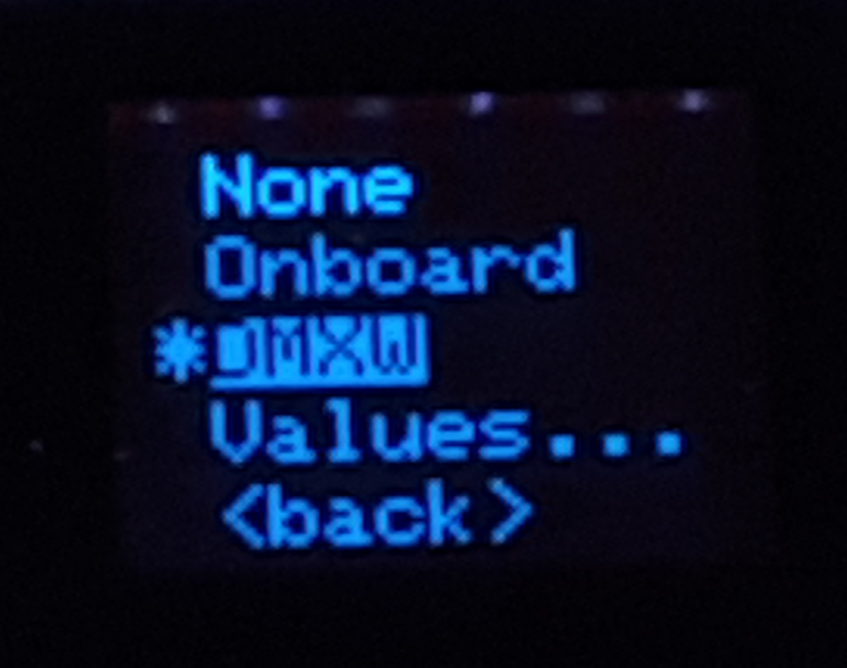Figure 9: Test outputs menu
Figure 10 shows the Channel Output Value Modification menu. You can scroll thru all of your selected active channels (refer to Figure 12) by using the + and – buttons. When you wish to modify a channel value, highlight that channel’s number (indicated to the left of the graphical slider) and press the Select button; the channel number will blink briefly to confirm it’s ready to be changed. Use the potentiometer to dial in the desired value. Then press either + or – to confirm the selected value and move on to the next channel. When you press the – button at the lowest numbered active channel, you will be taken back to the Test Output Selection menu.
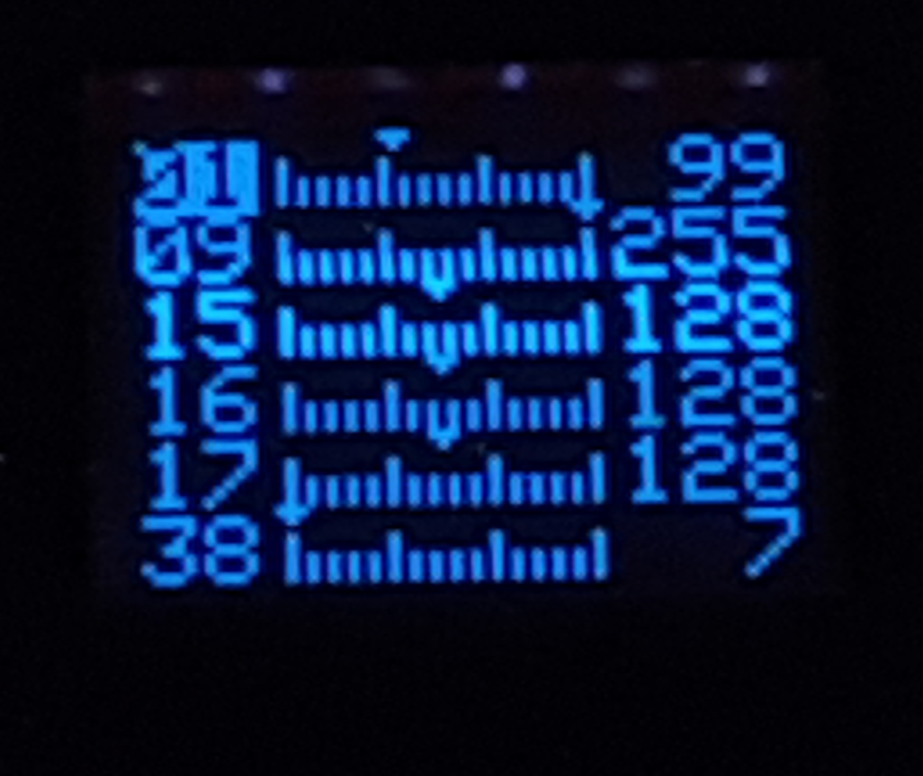Figure 10 Channel output value modification

Figure 11 shows the Test Type Selection menu. The menu items are as follows:
- Select None to disable all test types.
- Select Manual to run a manual test. When you start running the test, all selected active channels are set to their pre-configured values (refer to Figure 10); non active channels are all set to 0. You can also use the same Channel Output Value Modification menu to modify channel values on-the-fly.
- Select Sweep to run a channel sweep test. When the test is running, each channel is selected in turn and its channel values sweep thru values 0 to 255 and back down to 0 before moving on to the next channel. When the last active channel has been swept, the test cycles back to the first channel again.
- Select Pixel to run an animated rainbow effect on an addressable LED pixel string. This item only has an effect when the onboard test outputs are selected. The speed of the effect can be controlled using the onboard potentiometer.
- Select <back> to go back to the top level menu.
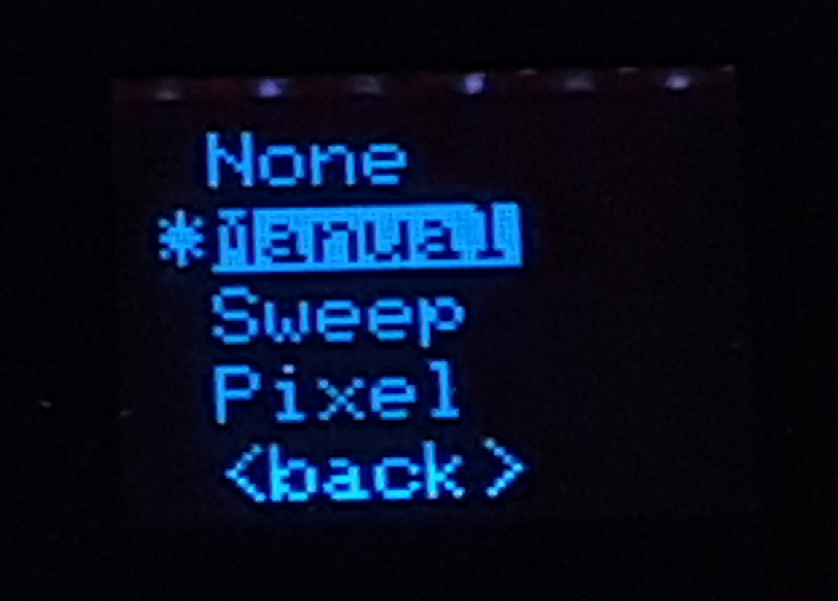Figure 11: Test type selection menu
Figure 12 shows the Active Channel Selection menu. This figure shows the display when the test output type is set to DMXW. Each dot or asterisk represents a channel. They are numbered sequentially, starting at channel #1 in the top left position. Each row contains up to 10 channels. So, the first row is channel #1 thru #10, the second row is channel #11 thru #20, etc. The last row contains channels #41 thru #48. Use the buttons as follows:
- Press the + button to move the selection highlight (in the figure ALL is currently highlighted) down to the next row. When something in the bottom row is selected, the highlight moves back to the top row (back to ALL).
- Press the – button to move the selection highlight to the left by one position (in the figure, <exit> would be highlighted next). When the leftmost item is selected, pressing the button moves the highlight to the rightmost item.
- Press the Select button to select the highlighted item:
  - Selecting ALL toggles between activating and deactivating all channels for the test.
  - Selecting <exit> takes you back to the top level menu.
  - Selecting any of the channels cycles thru the following:
* Channel will be active in the test.
P Channel will be active in the test and its value also will be under control of the
potentiometer. Only one channel can be under potentiometer control. If another
channel had been under potentiometer control, the selected channel overrides it.
. Channel will be non active in the test.
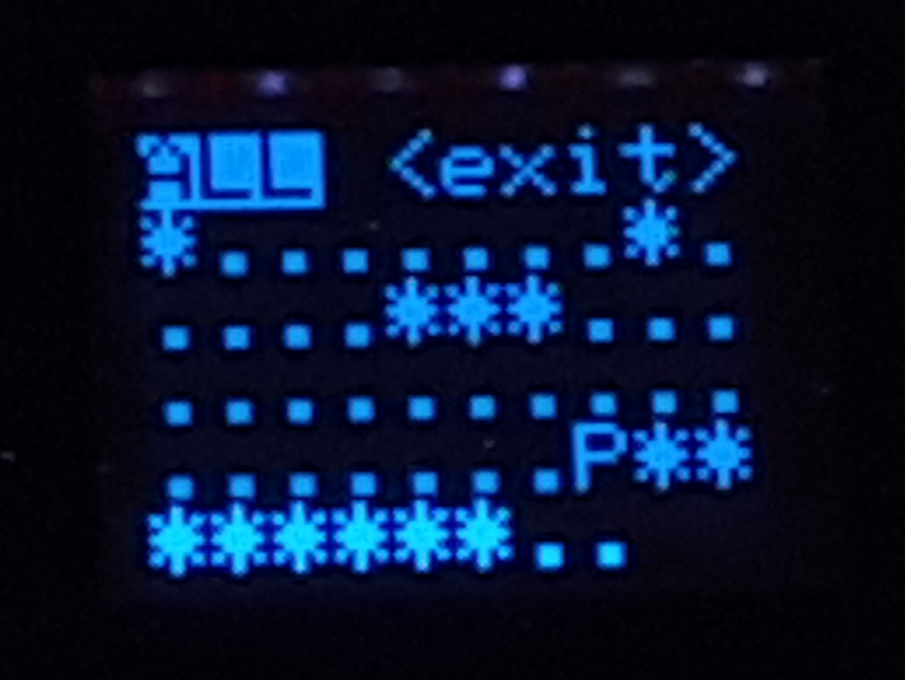Figure 12: Active channel selection menu

DMXW is an abbreviation for DMX-512 Wireless, a radio protocol that runs between a DMX-512 connected gateway controller and a number of low cost, customizable, battery operated remote slave units suitable for stage effects.
It looks like I introduced some capacitance by the way I hand wired the tester’s circuit board. When running Pixel strip tests on a 5 Vdc addressable LED pixel strip, an oscilloscope showed slow ramp-ups from 0 to 5 Vdc. The ramps are slow enough that a 5V pixel strip cannot be controlled properly. This is NOT an issue for a 12 Vdc pixel strip.
The rainbow test, as well as any other animated pixel string effect, can be run on DMXW remote slave nodes using a Manual DMXW test. Each of the effect parameters should be set according to the instruction provided for each effect. Note, however, that the DMXW node must be running the special pixel strip firmware.

